Title: Prototype Tooling VS Injection Molding: A Comprehensive Comparison for Product Developers

# Introduction

Efficient and cost-effective methods of manufacturing have always been a challenge for product developers. The two well-known manufacturing techniques that are most favored are prototype tooling and injection molding. Each of these approaches carries unique strengths and limitations. This article delves into the deep comparison between these two methods based on cost, time efficiency, material selection, complexity, design freedom, as well as quality to understand their differences thoroughly.

# What is Prototype Tooling?

Prototype tooling (also called rapid tooling) is an approach to manufacturing that allows making tools rapidly as well as cost-effectively in a short period of time. The tooling uses low-cost injection molds to make small batches of products. It is a type of injection mold tooling that is created rapidly at a cost-effective rate so that the complete analysis of the function, validation, and evaluation of your design can be done thoroughly before any mass production. Rapid prototyping tools speed up and make it less expensive to create new products.

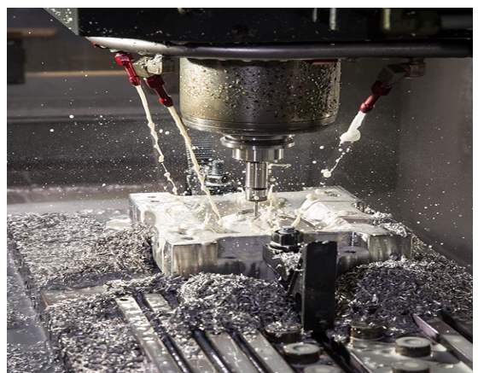

Figure Aluminium mold for prototyping(source: https://www.protolabs.com/services/injection-molding/prototyping/)

# Classification

**1. Soft Tooling:** Soft tooling is a cost-effective option ranging from low to medium-volume production whose flexibility allows for rapid design iterations, accommodates various materials, suits complex geometries, and also offers a smooth finish. It has limited material compatibility and longer cycle times. It lacks durability and wears out quickly. It is further divided into:

* Direct soft tooling
* Indirect soft tooling

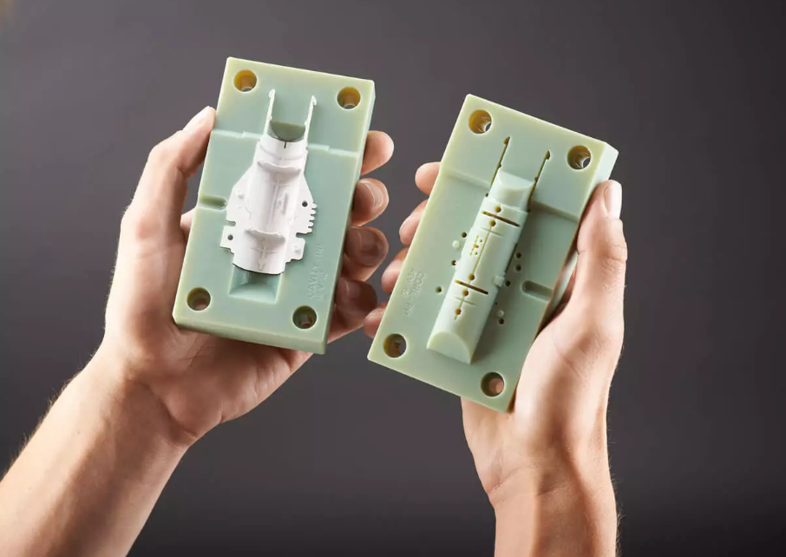

Figure Soft tooling molds(source: https://www.3erp.com/blog/soft-vs-hard-tooling-for-injection-molding/)

**2. Hard tooling:** Hard tooling is produced from durable materials like steel and is perfect for high-volume production that requires precision and durability while providing superior dimensional accuracy, material compatibility, and consistent quality. Its cost is more than soft tooling comparatively. Likewise, hard tooling are further divided into:

* Direct hard tooling
* Indirect hard tooling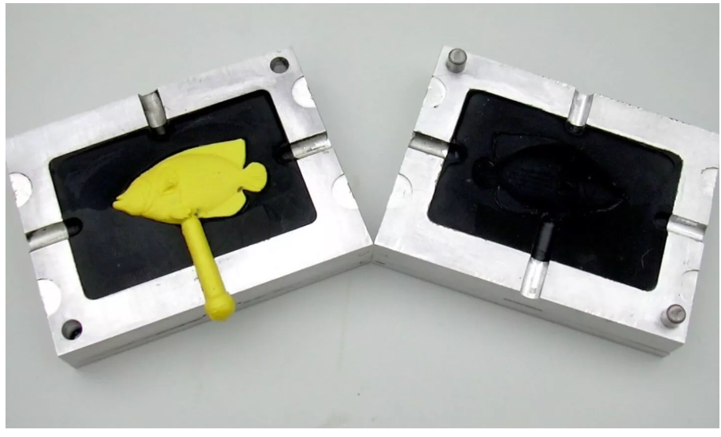

Figure Hard tooling mold

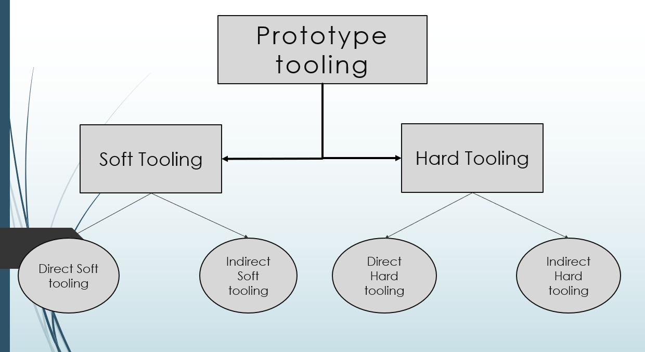

Figure Classification of prototype tooling

## Advantages of Prototype Tooling:

* Short tooling lead time: Tooling time is shorter than other types of tooling methods.
* Low Cost: Tooling cost is below 5 percent of other conventional kinds of tooling cost.
* Higher tool life: Tool life is significantly higher than others.
* High acceptance: It has a higher acceptance ratio than any other conventional tooling.
* Evaluation and validation: Prototype tooling allows functional testing and validation for the design before heading to mass production which helps in finding failure at early stages.
* Direct Transfer of CAD data: Imperfections that may occur due to misinterpretation of drawings can be avoided using a direct CAD model.

## Disadvantages

* Prototype tooling is less durable and robust.
* Creating multiple molds in this method may result in some dimensional errors.

# What is Injection Molding?

Injection molding is used in the manufacture of many popular plastic products such as bottle tops, syringes, remote control covers, and so on. This process involves placing the molten material in the mold where it cools and forms a solid final product. Injection molding is known for its efficiency, accuracy and ability to produce parts of precise sizes for a wide variety of products commonly used in our daily lives. In addition, it is also used for large-scale applications such as car body parts. In particular, injection molding is used where thousands or millions of uniform parts must be molded.

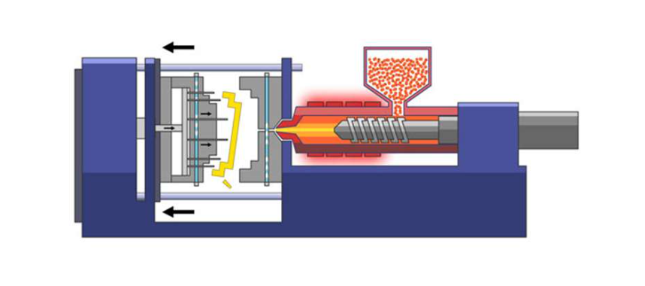

Figure 5 Injection molding (source: https://waykenrm.com/blogs/what-is-injection-molding/)

## Classification

There are many types of injection molding that have been under practice for many years and some of them are listed below:

1. Cube molding
2. Die casting
3. Gas-assisted injection molding
4. Liquid silicone rubber injection molding
5. Metal injection molding
6. Micro injection molding
7. Reaction injection molding
8. Thin-wall injection molding

## Advantages of Injection Molding

1. High efficiency and speed: It is a highly efficient process with the capacity of producing numerous quantities of parts rapidly.
2. Cost-effective in larger productions: Initial costs for setups are relatively high compared to the prototype tooling but the production cost decreases significantly with increments in production quantities. This makes injection molding economically an ideal choice where mass production is required.
3. Precise and tight tolerances: It offers tight tolerances in final parts with exceptional precision.
4. Flexibility with materials: Injection molding can be used with a variety of materials such as thermoplastics, thermosetting plastics, and elastomers.
5. Complex Geometry: Parts with complex geometries can be produced that would be difficult to manufacture using any other manufacturing techniques.
6. Minimum wastage: It generates final parts with exceptional precision leading to minimal wastage of excess material. Even wasted material can be reused.
7. Consistency and repeatability: Injection molding provides consistent as well as reproducible parts that are almost identical to each other.

## Disadvantages

1. This method has high start-up cost.
2. It requires longer initial lead times.
3. Design changes in this method are expensive.

# Cost Analysis

## Cost factors for prototype tooling

The factors that affect the total cost of prototype tooling are:

1. Design complexity: The cost of prototyping becomes high with more complex designs. Therefore design complexities become crucial factors for the cost of tooling. It is much less for simple geometries and very high for complex designs.
2. Size: Larger prototypes use more materials for prototyping and are therefore more expensive.
3. Materials: The type of material used for prototyping significantly impact the cost. Using high-quality materials like steel or aluminum may be more expensive than using plastic.

## Cost factors for injection molding

The cost of injection molding depends on several factors, including:

1. Order volume: Order volume is the most crucial factor for injection molding production. The cost per production is very low if the order volume is very high.
2. Part complexity: Complex parts require more time and effort to manufacture and are therefore more expensive.
3. Materials used: The type of material used for injection molding can significantly impact the cost.
4. Equipment cost: The cost of equipment for injection molding can vary greatly. This is a one-time investment cost. Professional industrial injection molding equipment costs between $50,000 and $200,000.
5. Labor costs: Most of the processes in injection molding are fully automated. However, costs like setup costs, repair costs, and operator costs come into play resulting increment in overall cost.

## Comparative cost analysis

*When comparing the cost-effectiveness between prototype tooling and injection molding, prototype tooling becomes more cost-effective for small production runs and rapid prototyping due to its lower initial setup costs and no extra labor costs. However, prototype tooling cost increases with design complexity and part size increase. In contrast, injection molding shines in mass production scenarios with lower per-unit production costs for larger order volumes. Although initial setup costs are high and extra labor costs come into play, the total cost per unit is very low compared to a single prototyped unit. Therefore, injection molding is a superior choice if the order volume is high.*

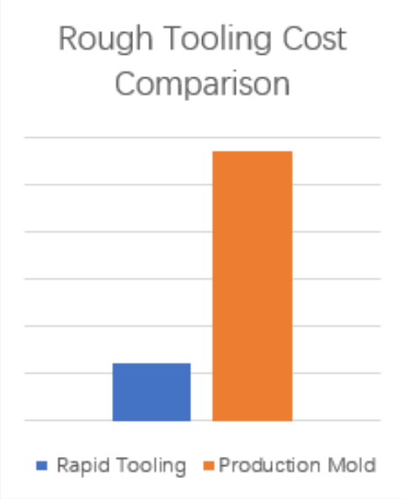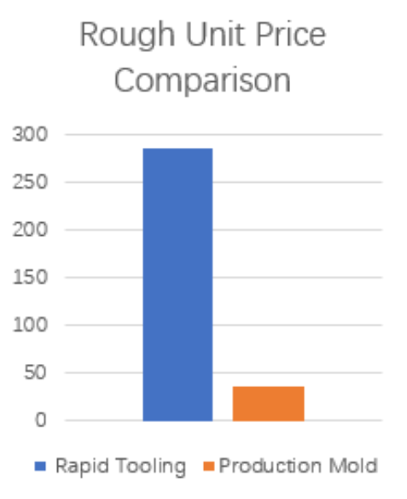

Figure 6 Comparison of rough tooling and unit price between prototype tooling and injection molding(source: https://www.dankemold.com/blog/comparison-between-rapid-tooling-and-production-injection-mold/)

# Time Efficiency

## Lead time for prototype tooling

The strategy for rapid tooling is to make a less durable tool that is engineered for a much shorter life than a conventional tool. This allows toolmakers to work with less expensive materials and faster manufacturing processes reducing waste. This is why, rapid tooling has a shorter production cycle because of the faster manufacturing speed.

## Lead time for injection molding

Injection molding is known for its longer lead times typically taking 5-7 weeks to manufacture tooling and an additional 2-4 weeks to produce and ship parts. This longer time is because the molds need careful design and testing which can take several months. Any changes in design further add to the turnaround time.

## Comparative time analysis

*Prototype tooling is used for shorter life spans with less expensive materials and faster processes. This results in a shorter production cycle. In contrast, injection molding needs mold design and testing which leads to longer lead times taking several months from tooling to final parts. Any design changes further extend the process.*

# Material Selection and Flexibility

## Materials commonly used in prototype tooling

* Aluminum Al 7075;
* Carbon steel C45, C50;
* Semi harden Steel P20;
* High polishing steel NAK 80;

Prototype tooling also offers compatibility with many plastics. However, it's crucial to note that abrasive materials such as glass-filled nylon can cause mold to wear. This shortens the tool's life. While this doesn't mean that you can’t use these materials. Careful consideration should be essential while working with such materials. Tool life isn’t a problem here if the required production number is low.

## Materials commonly used in injection molding

* Semi-harden steel 718, 2083, 8407, H13 and etc;
* Heat treatment would be needed;
* High polishing steel NAK 80, S136;

Injection molding materials range from commonly used polymers to specialty plastics and polymer blends. There are hundreds of different plastic resins available and they each have different end-use properties and processing requirements. Corrosive grades of plastic like PVC or POM can also cause an injection mold to wear more rapidly. Tool life is a crucial factor here as the production is on a large scale.

## Flexibility in material choice for each method

*In prototype tooling, the method aims to finish the production with the shortest lead time such that the part to be produced functions as intended. Tool life isn’t a crucial factor here thus the mold can be made using a wide range of plastics and soft metals. However, The mold has to go through multiple production under high pressure and temperature in injection molding. Thus, the tool life becomes a crucial factor in injection molding and is made up of semi-hardened steel like 718, 2083, 8407, H13, etc.*

# Complexity and Design Freedom

## How prototype tooling handles complex designs

Rapid tooling provides greater design flexibility and the ability to quickly incorporate design changes. Utilizing 3D printing and other cutting-edge rapid prototyping techniques allows for the effortless creation of intricate details, customized features, and complex geometries.

## How injection molding handles complex designs

Injection molding can handle complex designs once the production mold is set up. However, creating or modifying an injection mold can be a time-consuming and costly process which may limit design changes during the production phase.

## Comparison in terms of design constraints

*Flexible and quick design changes have been made possible by 3D printing and rapid prototyping. This allows prototype tooling methods for greater freedom in creating intricate, customized, and complex designs. In contrast, injection molding can produce complex designs but the time and cost associated with mold setup and modifications is a challenge. This results in the restriction of design changes during production.*

# Quality and Precision

## Quality considerations in prototype tooling

Prototype tooling creates prototypes that are slightly less precise compared to other tooling methods as its main purpose is to create a product that functions as intended rapidly and cost-effectively. Also, prototype tooling often uses materials that may not be as durable and are not resistant to chemicals and wear. As a result, the prototypes may exhibit minor variations and surface imperfections. So, the quality, surface finishes, and textures are not important here.

## Quality considerations in injection molding

Injection molding is known for its exceptional precision and consistency. It excels in producing parts with minimal variation ensuring tight tolerances and uniformity. Injection molding's ability to maintain consistent dimensions and high-quality finishes is crucial for applications where product quality and precision are paramount such as medical devices or automotive components.

## Comparative quality analysis

*Injection molding stands out over prototype tooling in precision and consistency. It produces parts with minimal variation and superior quality. In contrast, Prototype tooling is designed for rapid and cost-effective prototyping such that some sacrifices are made in precision and surface quality. Injection molding is a better choice if the quality finish is a priority despite lead time and cost.*

# Scalability

## Scalability options in prototype tooling

Prototype tooling is limited in terms of scalability. It is excellent for small-batch production and rapid prototyping. It may not be the most efficient choice for scaling up to mass production due to the need for new molds and tooling adjustments.

## Scalability options in injection molding

Injection molding is highly scalable once the production mold is in place. It can accommodate large production runs with minimal per-unit production costs.

## Which is better for scaling up production?

Injection molding is better suited for scaling up production due to its high scalability. It accommodates large production runs efficiently and cost-effectively. Prototype tooling may not be as efficient for mass production due to the need for new molds and adjustments.

# Case Studies

## Case Study: Prototype Tooling in Artificial Photosynthesis Technology

Innovation and product development often demand rapid tooling and flexible solutions. One of the real-world examples of this is the utilization of prototype tooling in the development of artificial photosynthesis technology as demonstrated by researchers at the University of California, Berkeley, and the Joint Center for Artificial Photosynthesis (JCAP).

The challenge they faced was to fabricate optical components swiftly for use in an artificial photosynthesis prototype. Traditional optical fabrication methods were very time-consuming and impractical for prototyping. Also, their need was for rapid design-to-part cycles and the capacity for quick design modifications

The team explored three different mold fabrication methods: CNC machining of plastic, CNC machining of aluminum, and 3D printing of plastic. Each method offered its own advantages and challenges. Notably, 3D printing was the most promising result as it allowed for rapid tooling production and could serve as "bridge tooling" while waiting for a hardened steel mold to be designed.

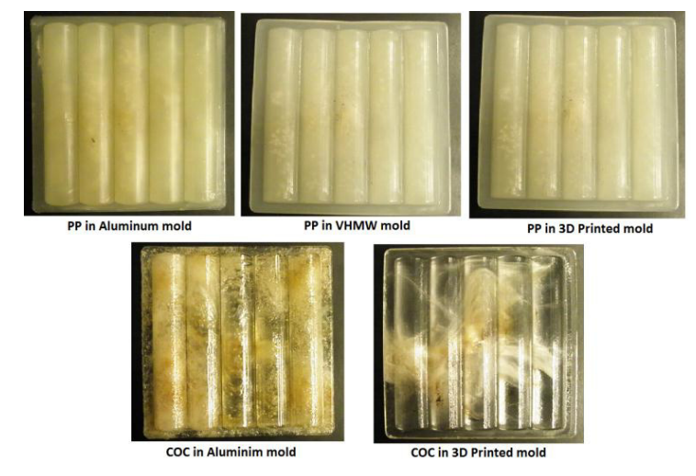

Figure PP and COC injection molded parts

These efforts immense the potential of prototype tooling in accelerating the development of innovative technologies such as artificial photosynthesis. Researchers were finally able to iterate and refine their designs easily by embracing the flexibility and speed of 3D printing for prototype tooling. Ultimately, it pushed the boundaries of what's achievable in the field of renewable energy and sustainable technology. This case study highlights the pivotal role that prototype tooling plays in propelling groundbreaking innovations to reality.

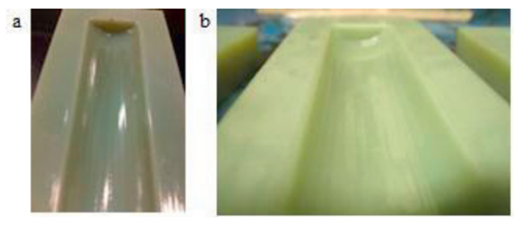

Figure Hot-pressed cavity (2) before molding (b) after molding

*(As printed, 3D printed parts have inadequate surface finish for molding optical components. Three finishing processes were explored. (1) hot-pressing with a steel shaft (2) coating with printer resin, and (3)mechanically polishing with a scraper and buffer.)*

Case study: Injection Molding Revolutionizing the Optical Industry

Injection molding of optical components has seen significant advancements in recent years enabling its use in various real-world applications. One such example is in the production of high-quality camera lenses for smartphones. Manufacturers have used injection molding to produce complex lens designs efficiently and cost-effectively as consumer demand for better camera performance has increased. This technology allows for the mass production of precise aspheric lens elements.

Another real-world application is in the automotive industry where injection molding is used to produce high-volume optical components such as headlamp lenses. These lenses must meet strict quality and safety standards. This created the need to make precision molding essential for ensuring optimal light dispersion and visibility.

Additionally, the use of injection-molded optical components has expanded into the medical field. Companies are producing diagnostic devices and medical imaging equipment with molded optical elements that offer excellent performance while keeping production costs down.

Therefore, we can conclude that injection molding of optics has found widespread use in various industries from smartphones and automotive lighting to medical devices demonstrating its versatility and cost-effectiveness in manufacturing high-volume optical components.

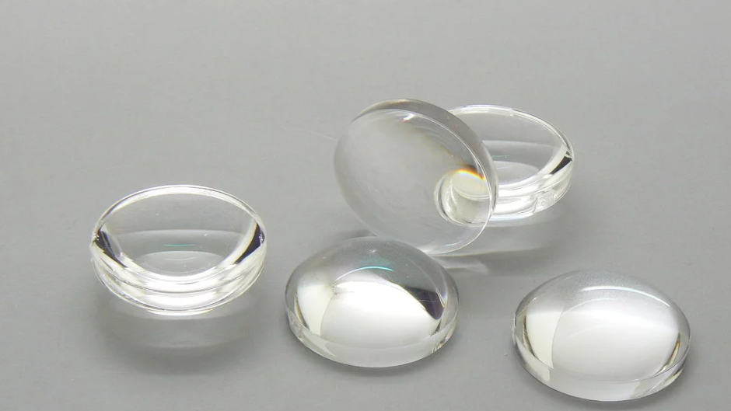

Figure Plastic Aspherical lens made by injection molding (source:https://sinoptix.eu/portfolio-item/pmma-injected-aspherical-lens/)

## Lessons learned and best practices

*Prototype tooling and Injection molding have their own advantages in product development. In the first case study, we learned that the prototype tooling using soft mold tools let the designers iterate their designs rapidly and cost-effectively. However, they had to compromise the quality of the mold. In contrast, the second study showed us the importance of injection molding in manufacturing at a large scale. Injection molding successfully produced a large number of lenses for various industries precisely with high quality.*

# Conclusion

Prototype tooling excels in rapid design iterations and cost-effective prototyping for small batches with a wide range of material choices. However, it sacrifices some durability and precision. Injection molding shines out in the mass production field with consistent quality, tight tolerances, and scalability although it demands higher initial costs and longer lead times.

You should choose prototype tooling for rapid prototyping, small-batch production, and quick design changes. And, injection molding should be the preferred choice when scalability, precision, and consistent quality are essential in large productions.

We would suggest considering your project's scale, budget, and quality requirements carefully when deciding between prototype tooling and injection molding to ensure the most suitable manufacturing approach for your product development needs is made.